**Sales of different TV Task 2:**

**Input**

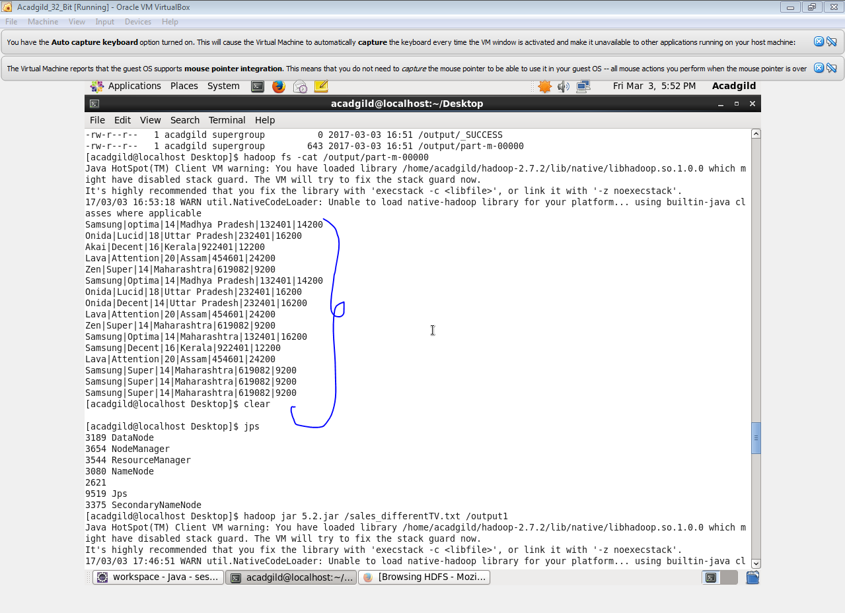

**Program**

**Driver class**

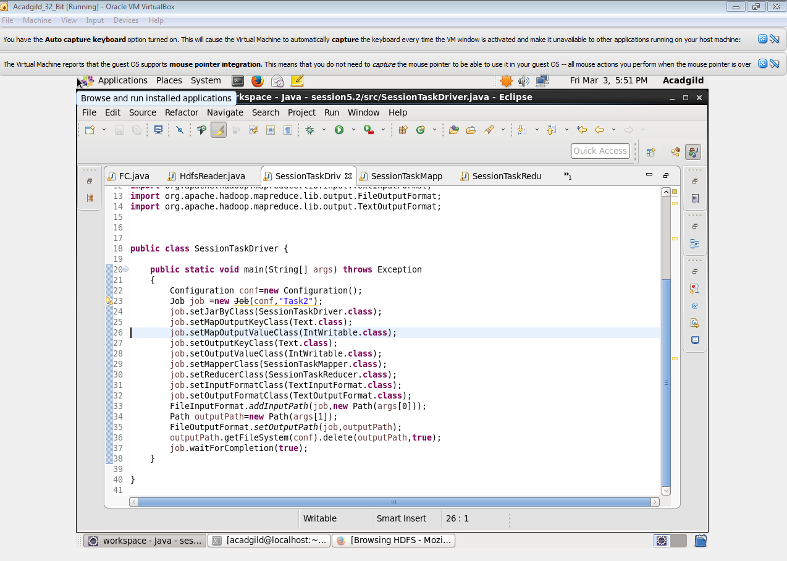

**Mapper class**

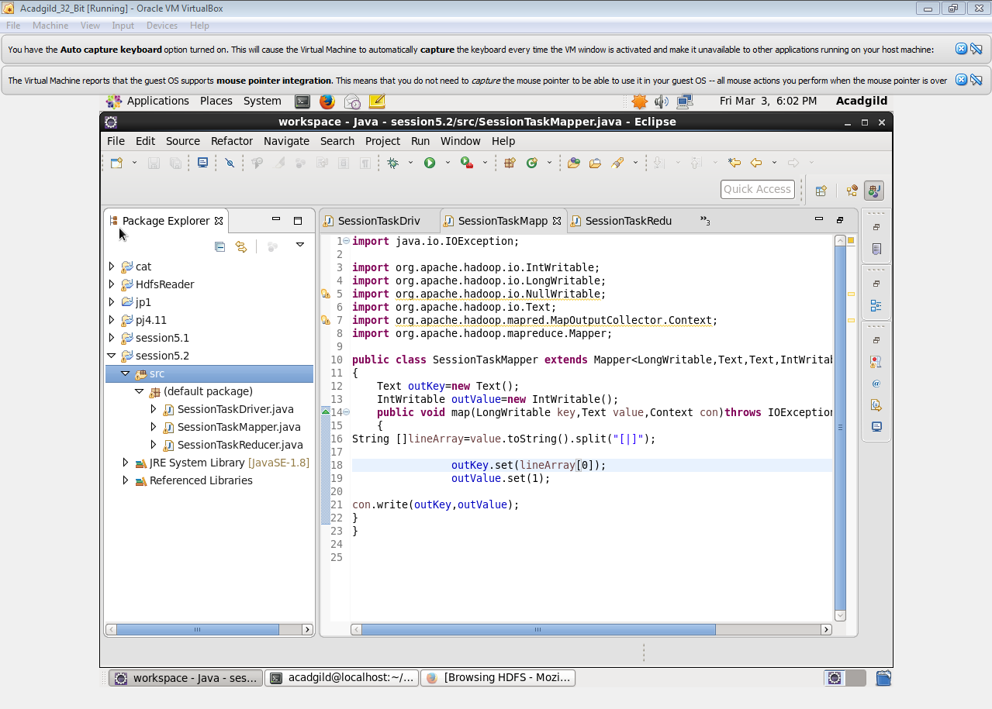

**Reducer class**

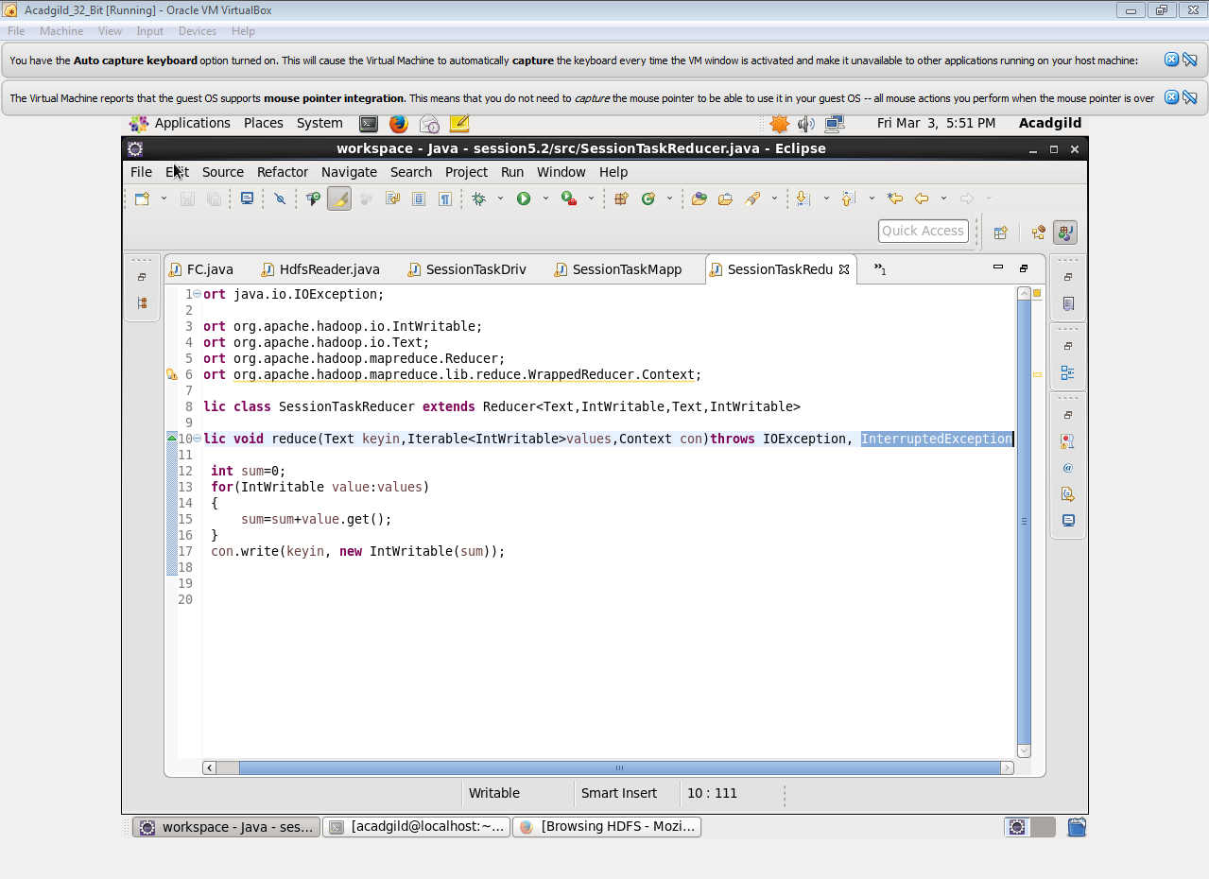

**Output**

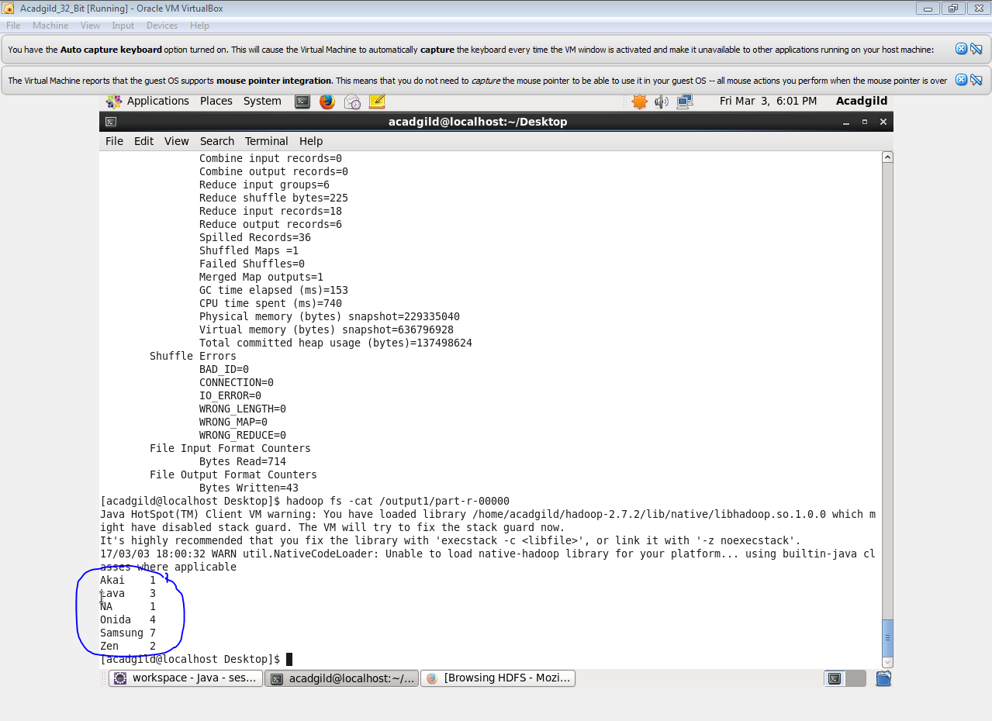

**Sales of different TV Task 3:**

**Write a MapReduce program to calculate the total units sold in each state for Onida company.**

**Input**



**Program**

**Driver class**



**Mapper class**

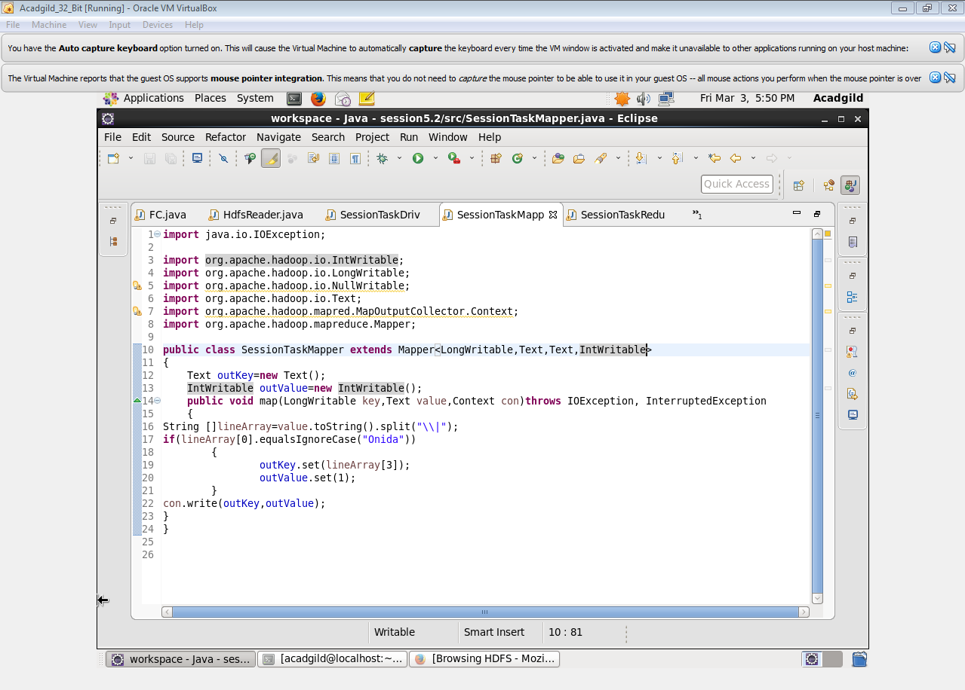

**Reducer class**



**Output**

